**A Journey of Building a Sustainable Mud Oven by Agastyans**

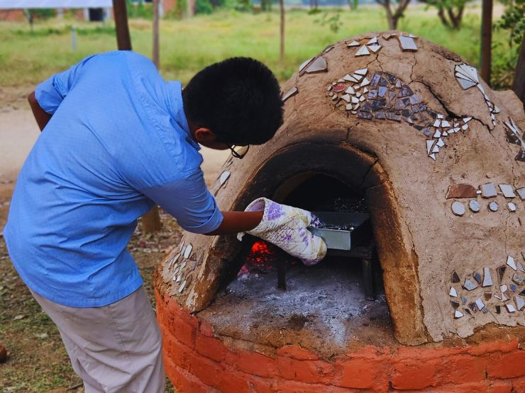

At Agastya, we're all about eating clean. So, when we wanted to make our own millet biscuits and muffins, we thought, "Why not add a touch of cooking tradition with mud?" It was a simple thought, like the mud benches we already had here and there even before I joined the school. Now, it’s been 2 whole years. In this blog, let me reminiscence and take you back in time into the Journey of Building Our Beloved Mud Oven at Agastya Academy!

[Read more….](https://www.agastyaacademy.edu.in/post/a-journey-of-building-a-sustainable-mud-oven-by-agastyans)